EXPT NO: 2 | COMPARATIVE STUDY OF ACTIVATION FUNCTIONS AND OPTIMIZATION ALGORITHMS IN DEEP LEARNING
DATE:

PRE-LAB QUESTIONS (PROVIDE BRIEF ANSWERS TO THE FOLLOWING QUESTIONS)

- What is the purpose of an activation function in an Artificial Neural Network?
An activation function introduces non-linearity into a neural network, enabling it to learn complex patterns and relationships. Without activation functions, an ANN behaves like a linear model regardless of the number of layers.
- Differentiate between the Sigmoid, Tanh, and ReLU activation functions based on their output range and mathematical properties.
Activation Function | Output Range | Simple Feature
Sigmoid | 0 to 1 | Used for binary classification
Tanh | -1 to 1 | Better than Sigmoid because it is zero-centered
ReLU | 0 to ∞ | Fastest and most commonly used

- Why is an optimization algorithm required during neural network training?
Optimization algorithms update the network's weights and biases by minimizing the loss function using gradients. They help the model converge faster and improve prediction accuracy.

- What is the difference between Batch Gradient Descent, Stochastic Gradient Descent (SGD), and Mini-Batch Gradient Descent?
Method | Weight Update | Speed | Memory
Batch Gradient Descent | Entire dataset | Slow | High
SGD | One sample at a time | Fast but noisy | Low
Mini-Batch Gradient Descent | Small batches | Fast and stable | Moderate

- Explain the role of Google Colab and GitHub in deep learning experiment management.

Google Colab
- Provides free GPU/TPU support.
- Executes Python notebooks online.

GitHub
- Stores project code.
- Maintains version history.
- Enables collaboration.
- Supports experiment reproducibility.

AIM
To analyze the impact of different activation functions and optimization algorithms on the performance of Artificial Neural Networks (ANNs) and to learn best practices for managing deep learning experiments using cloud-based tools and version control.

SOFTWARE REQUIREMENTS
- Python
- TensorFlow or PyTorch
- Google Colab
- GitHub
- Matplotlib

OBJECTIVES
Students will be able to:
- Understand the role of activation functions in neural networks.
- Visualize and compare commonly used activation functions.
- Evaluate the performance of different activation functions in ANN models.
- Analyze various gradient-based optimization algorithms.
- Compare optimizer convergence and model accuracy.
- Learn experiment management using Google Colab, Google Drive, and GitHub.
- Maintain reproducible deep learning experiments using version control.

PROCEDURE
PART A: VISUALIZATION OF ACTIVATION FUNCTIONS
Implement and plot the following activation functions:
- Sigmoid
- Tanh
- ReLU
Compare their:
- Output range
- Saturation regions
- Gradient behavior
- Computational efficiency
- Typical applications

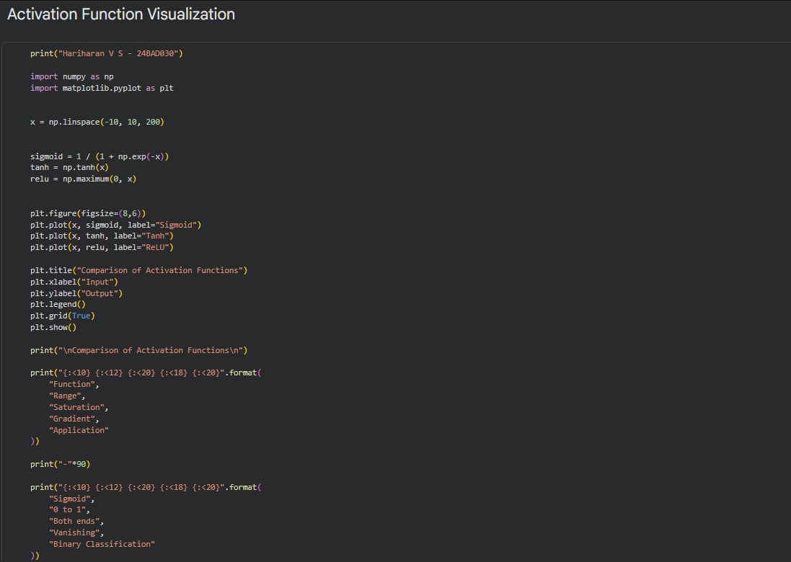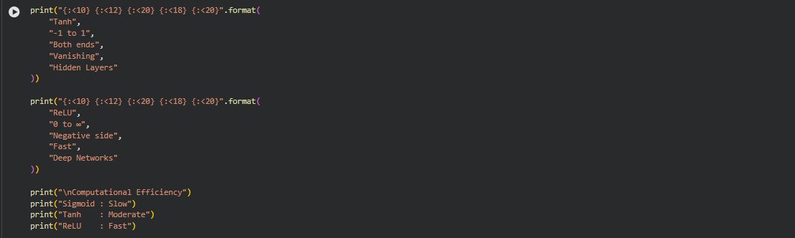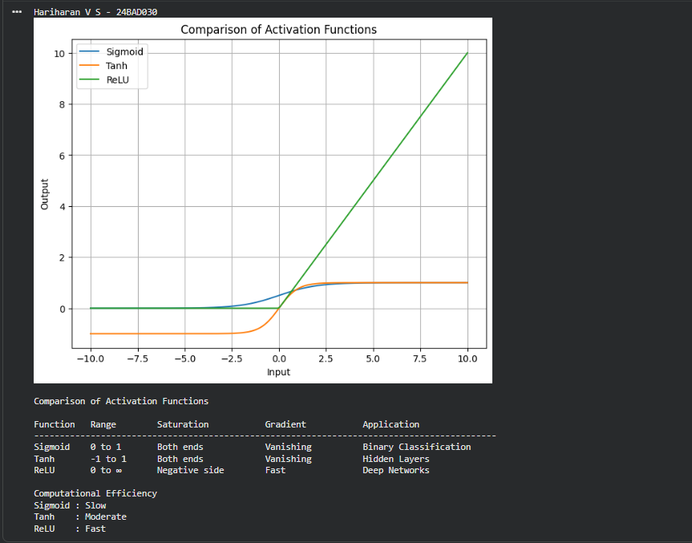

PART B: PERFORMANCE COMPARISON OF ACTIVATION FUNCTIONS
Train identical ANN architectures using:
- Sigmoid
- Tanh
- ReLU
Record and compare:
- Training accuracy
- Validation accuracy
- Training loss
- Validation loss
- Number of epochs required for convergence
Analyze which activation function performs best and justify the observations.

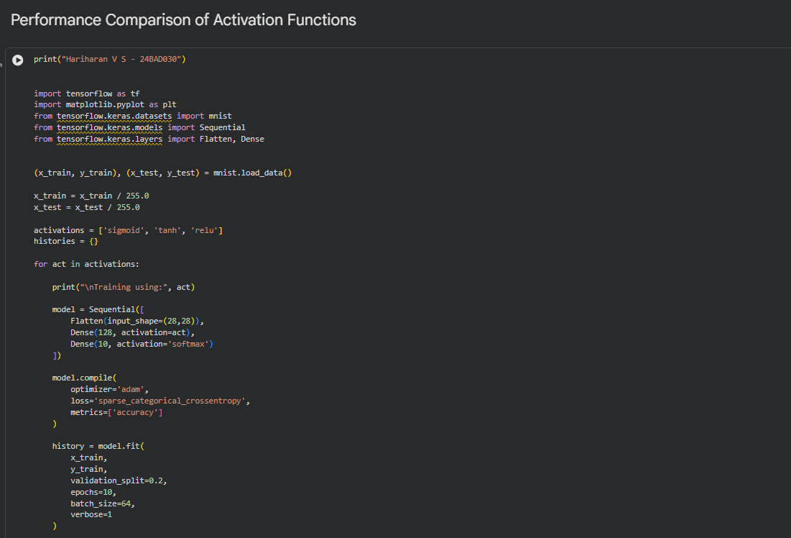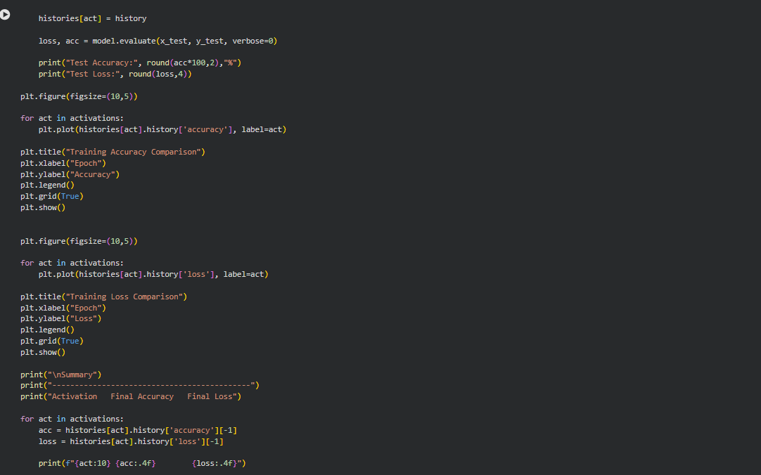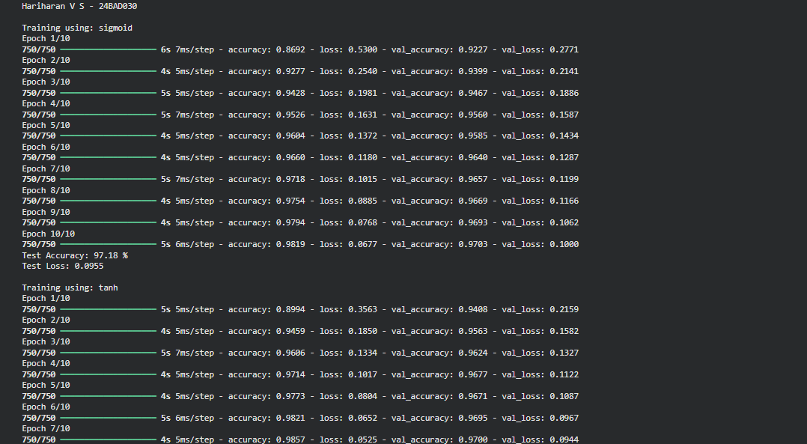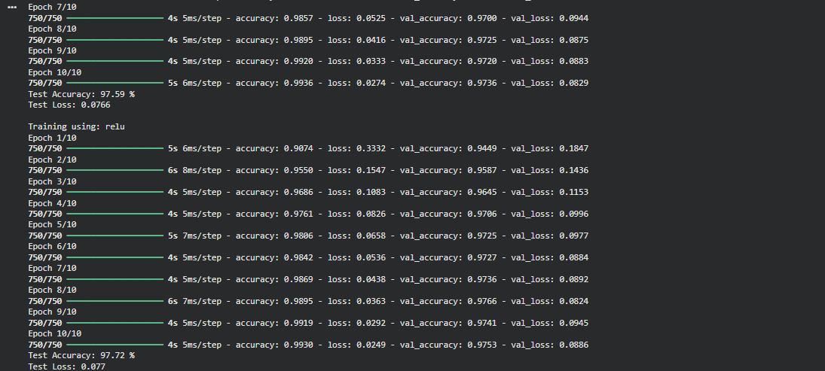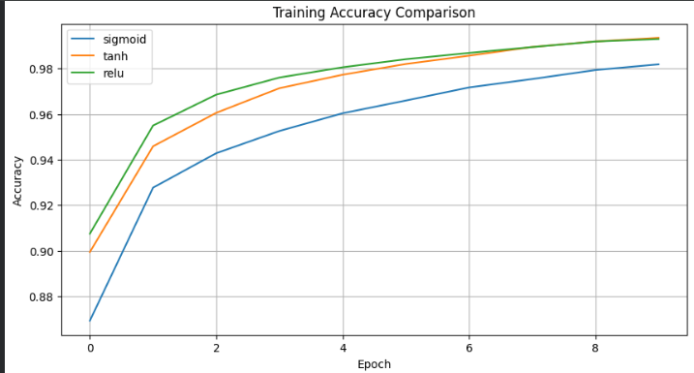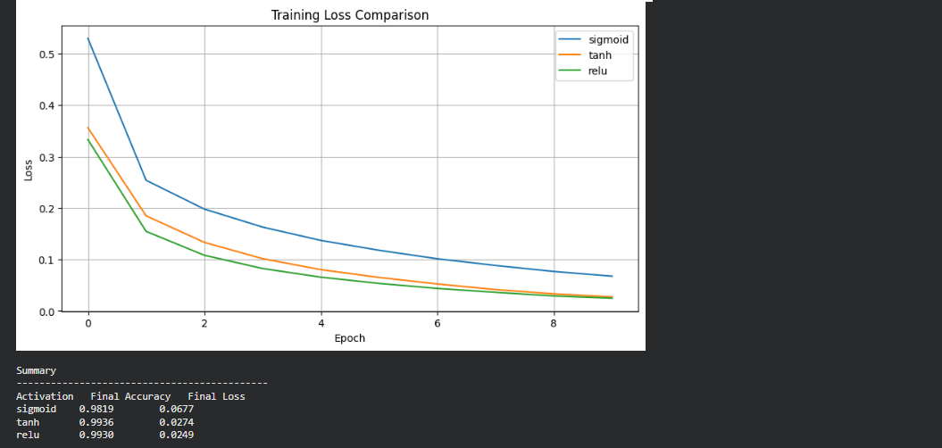

PART C: COMPARISON OF OPTIMIZATION ALGORITHMS
Train the same ANN using:
- Stochastic Gradient Descent (SGD)
- Momentum
- RMSProp
- Adam
Compare:
- Training loss
- Validation loss
- Convergence speed
- Final training accuracy
- Final validation accuracy
Visualize:
- Loss vs Epoch
- Accuracy vs Epoch
Discuss which optimizer converges faster and produces better generalization.

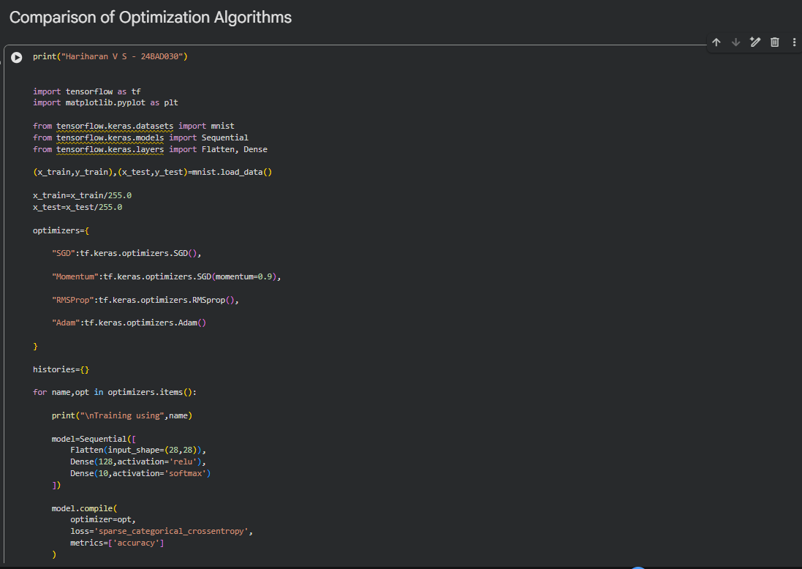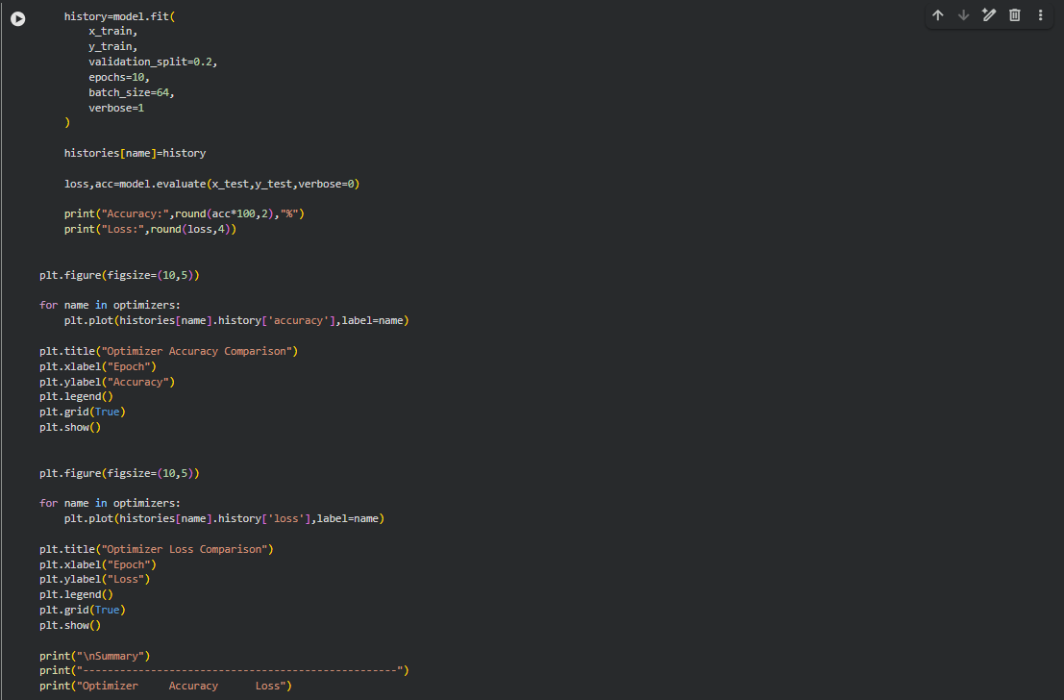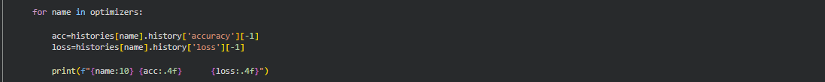

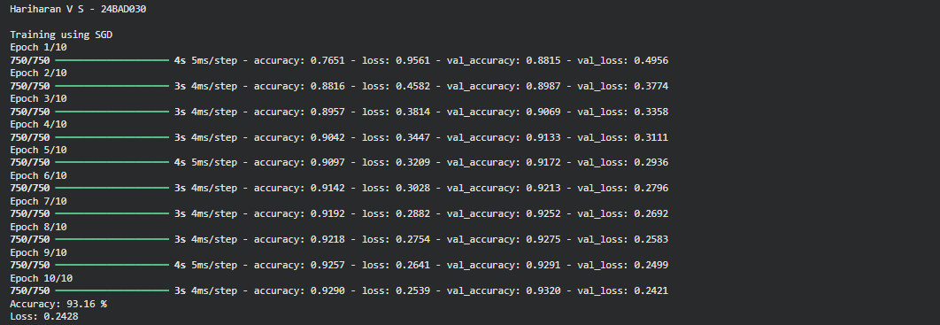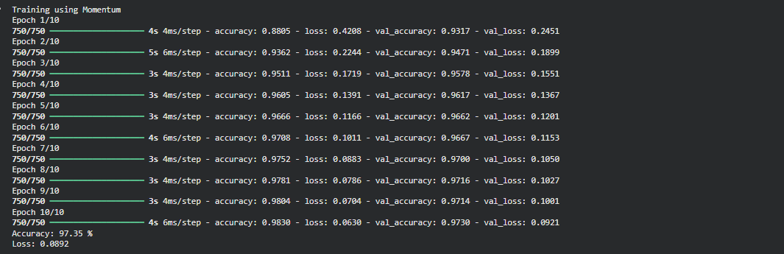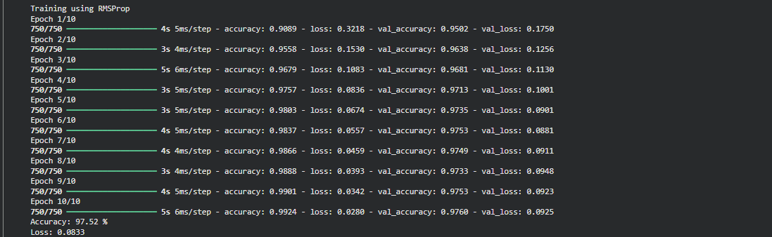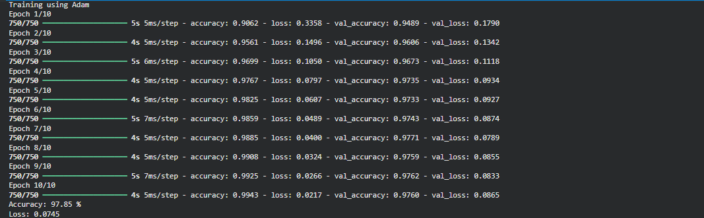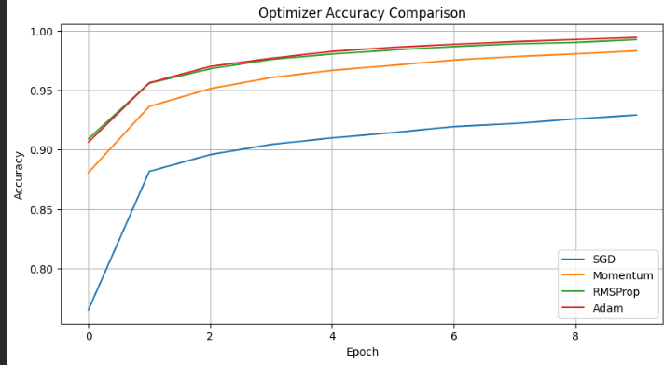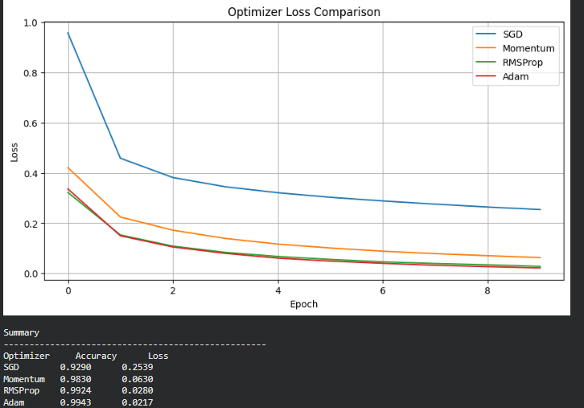

PART D: DEEP LEARNING EXPERIMENT MANAGEMENT
Perform the following tasks:
- Create a Google Colab notebook.
- Mount Google Drive.
- Save notebooks and trained models.
- Create a GitHub repository.
- Upload notebooks to GitHub.
- Commit changes and maintain version history using Git.
- Document the experiment using a README.md file.

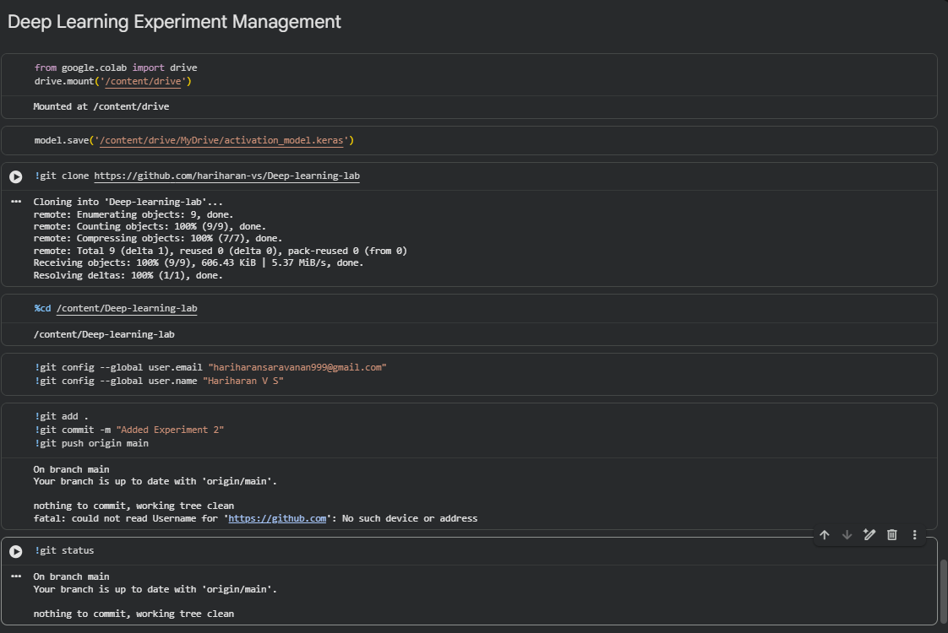

EXPECTED OUTCOME
Students will understand how activation functions and optimization algorithms influence neural network learning and performance. They will also gain practical experience in organizing, documenting, and maintaining reproducible deep learning experiments using cloud platforms and Git-based version control.

POST-LAB QUESTIONS (PROVIDE BRIEF ANSWERS TO THE FOLLOWING QUESTIONS)

- Which activation function achieved the best performance in your experiment? Justify your answer using the obtained results.

ReLU achieved the best performance because it provided the highest training and validation accuracy with the lowest loss. It converged faster than Sigmoid and Tanh due to its simple computation and reduced vanishing gradient problem.

- Compare the convergence behavior of SGD, Momentum, RMSProp, and Adam based on the training graphs.

Optimizer | Convergence Speed | Performance
SGD | Slow | Moderate
Momentum | Faster than SGD | Better stability
RMSProp | Fast | Good for adaptive learning
Adam | Fastest | Highest accuracy and lowest loss

- Why does the ReLU activation function generally train faster than the Sigmoid activation function?
ReLU avoids the vanishing gradient problem for positive inputs and requires only a simple max operation, making computation faster and allowing deeper networks to learn efficiently.
- How does version control using GitHub improve the reproducibility and collaboration of deep learning projects?
GitHub maintains version history, tracks code changes, enables multiple developers to collaborate, supports rollback to previous versions, and allows sharing of experiments, making research reproducible.

- If you were asked to train a deep neural network for an image classification task, which activation function and optimizer would you choose? Justify your selection based on the experimental observations.
I would choose ReLU as the activation function and Adam as the optimizer. ReLU provides faster learning and reduces the vanishing gradient problem, while Adam combines Momentum and adaptive learning rates to achieve faster convergence and higher accuracy.

ASSESSMENT
Description | Max Marks | Marks Awarded
Pre Lab Exercise | 5
In Lab Exercise | 10
Post Lab Exercise | 5
Viva | 10
Total | 30
Faculty Signature

